SENNHEISER’s HEADSET TRADE-IN PROGRAM ENCOURAGES END-USERS TO “BREAK-UP WITH BAD AUDIO” AND receive AN SDW 5000 AT NO COST

Sennheiser’s “Trade-In & Trade-Up” Program lets businesses jettison sub-par headsets and switch to Sennheiser premium audio solutions, delivering a quality communications experience to their customers

Old Lyme, CT, August 30, 2018 – Sennheiser, a leading provider of premium audio solutions, has launched its new “Trade In & Trade Up” program, calling upon businesses to improve the quality of their communications by replacing inferior headsets with premium audio technology. Aimed at companies throughout North America, the program is designed to highlight the dramatic productivity gains that sophisticated audio solutions can produce in the typical collaborative workplace compared to lower-shelf, legacy headsets. Sennheiser has created an opportunity for businesses to refresh their existing audio technologies and replace them with the new SDW 5000 Series communications hub, with the objective of banishing sub-par audio experiences. The high-quality SDW 5015 and SDW 5016 headsets allow users to connect via desk phone, cell phone, PC, or other mobile devices through a unique base unit, accommodating high-quality communications from a variety of devices and environments.

Through this promotion, businesses that purchase Sennheiser products from an authorized reseller can trade-in competitive (Plantronics and/or Jabra headsets) DECT or corded headsets and receive a cutting-edge Sennheiser SDW 5000 series headset at no cost; see program details below. Similarly, business end-customers who utilize Sennheiser SD Series or D10 DECT headsets have the opportunity to “trade up” their past and new purchases to receive free unit/s of the new SDW 5000 Series headsets. The program requires eligible companies to purchase a corresponding amount of Sennheiser SDW 5015 or SDW 5016 headsets as part of the trade. Interested parties can email CCOEVENTS@sennheiser.com to find out more about the program.

According to global service provider BT Business, 85% of callers who can't communicate with a company on the first try won't call back—evidence of the dire role that communications plays in growing the bottom line.

“Today’s workplace is rife with innovation. Consumers will no longer tolerate low-grade audio quality, which denigrates the customer engagement experience,” confirmed Tori Seliokas, channel manager, Sennheiser enterprise solutions. “Our new Trade In & Trade Up promotion makes it easy for companies to dismiss inferior audio quality, renewing their commitment to customers and facilitating a state-of-the-art communications experience. Our new SDW 5000 makes the promise of clear, consistent, and versatile audio communications a daily occurrence, instead of an anomaly.”

Headset models to be traded can be in any condition: new, used, or even damaged. This presents a significant opportunity for businesses to refresh and improve their communications networks by switching to Sennheiser’s newest, cutting-edge headsets—receiving one such unit at no cost in the process. The Trade In & Trade Up program runs from now until December 31, 2018.

“The Sennheiser SDW 5000 headset is not just a DECT product,” Seliokas added. “The device has been engineered as a communications hub to address the shifting variables of the contemporary workforce. This is an especially poignant feature since most users—especially tech-savvy Millennials now entering the marketplace—use different devices over the course of the day.”

Sennheiser’s SDW 5015 and 5016 headsets are part of the new SDW 5000 Series for collaborative, open workspaces. In addition to the SDW 5015 and SDW 5016’s connectivity options and superior sound quality, the headset boasts industry-leading security encryption that defies hackers. And the series’ three wearing styles (headband, over-ear hook, or neck band) increase the wide-based appeal and all-day usability of the product.

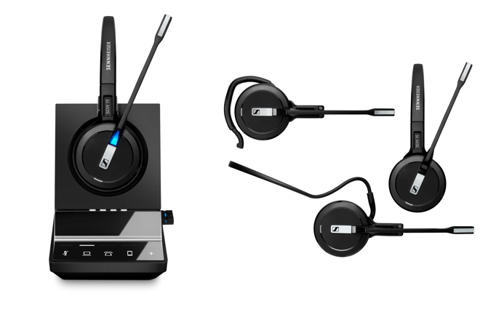 | Modern businesses need to acknowledge the urgency of quality audio as collaborative spaces become more sophisticated. Sennheiser’s SDW 5015 and SDW 5016 headsets deliver advanced security, Super Wideband sound, and enhanced connectivity with mobile phones, desk phones, PCs, and other devices.

The Trade-in & Trade Up program parameters are as follows:
Sennheiser business customers can trade-in Plantronics and/or Jabra DECT and corded headsets for a new Sennheiser SDW 5000 headset. Or, existing Sennheiser customers, can trade-up their legacy Sennheiser headsets to the new SDW 5000, along with purchases.
Trade-in options:
- Business customers can trade in five units of competitive wired and/or wireless headsets (Plantronics and/or Jabra) and receive one new SDW 5015 headset at no cost, with the purchase of five units of Sennheiser SDW 5015 headsets.
- Business customers can trade in six units of competitive wired and/or wireless headsets (Plantronics and/or Jabra) and receive one new SDW 5016 headset at no cost with the purchase of six units of Sennheiser SDW 5016 headsets.
Trade-up options for existing Sennheiser business customers:
- Existing Sennheiser customers who purchase 10 units of the new SDW 5015 and receive one SDW 5015 headset at no cost. Proof of prior purchase of Sennheiser SD and/or D10 Series headsets is required.
– Existing Sennheiser customers who purchase 11 units of the new SDW 5016 headsets receive one SDW 5016 headset at no cost. Proof of prior purchase of Sennheiser SD and/or D10 Series headsets is required.

“In an age when collaboration is key, and commerce is conducted over a multitude of platforms, it’s time for businesses to invest in more sophisticated headset technology. Audio quality simply can’t be an afterthought if an organization wants to excel in this challenging, saturated marketplace,” Seliokas continued.

All claims through the Trade In & Trade Up program must include the end-user’s proof of purchase for the Sennheiser SDW 5000 Series headsets along with the units to be traded or upgraded. End-customers may procure the Sennheiser headsets from their authorized reseller any time during the August 1 to December 31, 2018 timeframe to be eligible. Trade-ins and trade-ups claims must be received by January 28, 2019. Business customers can email CCOEVENTS@sennheiser.com for more details on how and where to ship models for trade-in or upgrade, and for complete program rules.

about Sennheiser
Sennheiser is shaping the future of audio – a vision built on more than 70 years of innovation culture, which is deeply rooted within the family-owned company. Founded in 1945, Sennheiser is one of the world’s leading manufacturers of headphones, microphones and wireless transmission systems. With 20 sales subsidiaries and long-established trading partners, the company is active in more than 50 countries and operates its own production facilities in Germany, Ireland and the USA. Sennheiser has around 2,800 employees around the world that share a passion for audio excellence. Since 2013, Sennheiser has been managed by Daniel Sennheiser and Dr. Andreas Sennheiser, the third generation of the family to run the company. As part of the Sennheiser Group, the joint venture Sennheiser Communications A/S is specialized in wireless and wired headsets and speakerphones for contact centers, offices and Unified Communications environments as well as headsets for gaming and mobile devices. In 2016, the Sennheiser Group had sales totaling €658.4 million. www.sennheiser.com
Local Contacts PR Contact Sennheiser Communications A/S

Suzanne Mattaboni Tanja Krebsø
PR Manager T +45 2535688
Hummingbird Media, Inc. takr@senncom.com
(610) 261-4560
(610) 737-2140 cell
suzanne@hummingbirdmedia.com

Jeff Touzeau
Public Relations
Hummingbird Media, Inc.
(914) 602-2913
jeff@hummingbirdmedia.com

